NHDPlus Release Notes for
Region 15
Last Updated 8/2/2010

Data Release Note – 8/2/2010 – Flowline_Cat_Attr V01_03 Released

Two changes have been made to the FlowlineAttributesFlow Table: (1) All zero slopes have been changed to a nominal slope of 0.00005; and (2) the corresponding MAVELU and MAVELV estimates have been updated using the Jobson “slope” method for all Flowlines where these slopes have been changes. The result of this change is that the Jobson “noslope” method is never used. The reason for this change is that the NHDPlus Team has determined that the “noslope” method is not appropriate for zero slope applications. The Jobson velocity calculations are described in Appendix A- Step 6 of the NHDPlus User Guide.

Data Release Note – 10/17/2008 – NHD Component V01_03 Released
NHDFlowlineVAA.StreamOrde was set to zero to indicate that users are directed to use the new Stream Order/Stream Calculator fields that are available from the Data Extensions tab on the www.horizon-systems.com/NHDPlus web page.

Data Release Note – 7/16/2007 – NHD Component V01_02 Released
Extraneous fields were removed from the NHDFlowline attribute table.

Release Note 06/05/2007 – The problem with IncrFlowU in FlowlineattributesFlow Tables has been corrected.
New data is available in the NHDPlus15V01_02_Cat_Flowline.zip file.

Release Note 12/13/2006 – Problem with IncrFlowU in FlowlineattributesFlow Tables
In several of the HydroRegions there are incorrect values for the IncrflowU field. This problem exists when the UROM flow computations attempt to compensate for consumptive use by applying only a proportion of the unit runoff flow on intermittent streams. These incorrect IncrFlowU values can be corrected as follows:

If FCODE <> 46003, then:
In HydroRegion 10, the correct IncrFlowU = IncrFlowU / 0.05
In HydroRegion 11, the correct IncrFlowU = IncrFlowU / 0.75
In HydroRegion 13, the correct IncrFlowU = IncrFlowU / 0.20
In HydroRegion 14, the correct IncrFlowU = IncrFlowU / 0.05
In HydroRegion 15, the correct IncrFlowU = IncrFlowU / 0.05
In HydroRegion 16, the correct IncrFlowU = IncrFlowU / 0.05
In HydroRegion 17, the correct IncrFlowU = IncrFlowU / 0.10
In HydroRegion 18, the correct IncrFlowU = IncrFlowU / 0.10

This problem does not affect any other HydroRegions or any other fields in the FlowlineattributesFlow Table.

Data Release Note – 07/16/2006 – Zip File Construction Problem with Grids
It was determined that the elevation, flow direction and flow accumulation grid zip files were not constructed correctly. When the grids were unpacked they overwrote each other’s info directory. The grids have been reposted as version V01_02.

Data Release Note – 6/15/2006 – Data Source for Mexico Catchments:
The NED data for Region 15 extended into Mexico far enough to delineate the catchment areas that flow into the U.S. No additional source material was used.

Data Release Note – 6/15/2006 – Returning flows
Some streams that flow out of the US and subsequently return to the US were missed in the initial processing. Most were very small, accounting for around a dozen or fewer catchments each. One, the Santa Cruz River near Lochiel, AZ, was larger. Approximately 90-100 square miles of drainage area drain into the four flowlines that should have been connected to the Santa Cruz River near Nogales, AZ (ComID 15908005). The following table gives the ComID’s of the flowlines leaving the US, the ComID of the flowline that ultimately receives the flow back into the US, and the Reach Code of the receiving flowline.

COM_ID | RTNUSCOMID | RTNUSRCHCD
15934675 | 15934663 | 15050202001022
15934681 | 15934663 | 15050202001056
15907987 | 15908005 | 15050301000350
15907989 | 15908005 | 15050301000349
15908231 | 15908005 | 15050301001267
24956581 | 15908005 | 15050301001482
15844382 | 15844342 | 15080101000361
20372871 | 20372869 | 15080301000508
20372873 | 20372869 | 15080301000509
20372875 | 20372869 | 15080301000510

These errors will be addressed at a future time, depending on availability of resources needed to accomplish the task.
- The following illustration shows the Santa Cruz River area:
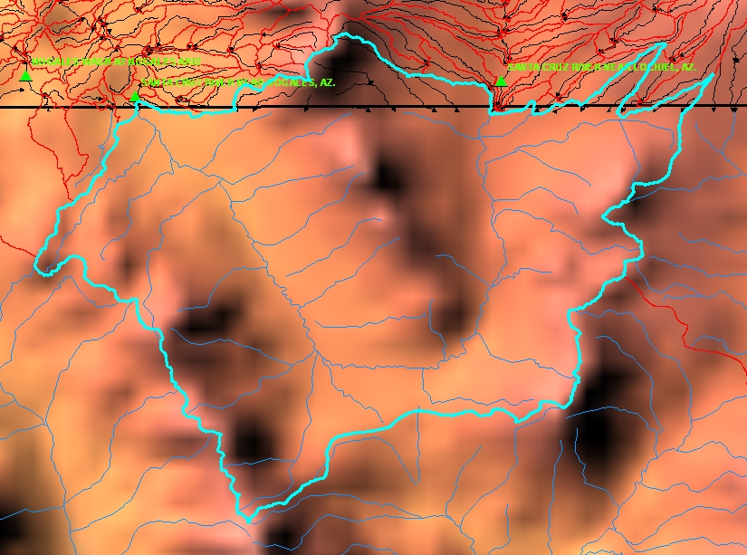

Data Release Notes – 6/15/2006 – Slope and Velocity Errors

After slope was computed and flow volume and velocity was run, errors were found in the LengthKM field of a small number of NHDFlowlines. Because of the limited impact and the estimated expense to correct the problems, only the LenghtKM field was corrected. Small errors still exist in slope and velocity. The affected flowlines are shown in the table below.

ComID | LengthKM in Error | Corrected LengthKM
916090011 | 0.455 | 0.43
916150003 | 2.008 | 1.842
916090012 | 0.24 | 0.26
20573279 | 4.617 | 3.939
21398359 | 0.353 | 0.278
916130003 | 0.461 | 0.607
120299800 | 2.232 | 3.069

Data Release Notes – 6/15/2006 – Placement of Sinks
Nodata sinks were applied to the HydroDEM flow direction and flow accumulation grids at the outlet of isolated networks within closed 8-digit hydrologic subbasins. The closed basins are listed below:

15050201 – Willcox Playa. Arizona
15040003 – Animas Valley. Arizona, New Mexico

Sinks were also applied at terminating reaches along the U.S./Mexican border where water was flowing into Mexico from the U.S.. See NHDPlus15V01_01_QAQC_SINKS.xls which is posted with the NHDPlus data.

Data Release Notes – 6/15/2006 – Application of the Watershed Boundary Dataset
The Watershed Boundary Dataset (WBD) was used in the HydroDEM production process to insure NHDPlus Catchments conformed to these boundaries. Only data from states where the certified WBD existed was used. For Hydroregion 15, the WBD was applied in Utah only. For more information on WBD see the NHDPlus Metadata file.

Data Release Notes – 6/15/2006 – Drainage Area
NHDPlus drainage area estimates above 10,000 sq. km. are less than the gage drainage area estimates, primarily due to differences in the Gila River Basin plus the upstream drainage area estimates from Hydroregion 14. The gages seem to provide total drainage area while the NHDPlus drainage areas estimate contributing area as based on the NHDPlus connectivity. There is a significant difference in the NHDPlus and gage drainage area estimates at the two most downstream gages on the Colorado River. A cross-check of the sum of the areas of the 1:250,000 HUC-8’s in HydroRegions 14 and 15 is 650,700 sq. km. The most downstream gage on the Colorado River gives a drainage area of 639,000 sq. km. This is a difference of 2%, strongly indicating that the gage drainage area estimate is total drainage area and NHDPlus is based on contributing drainage area. See NHDPlus15V01_01_QAQC_SINKS.xls which is posted with the NHDPlus data.

Data Release Notes – 6/15/2006 – Flow
The UROM attempts to compensate for consumptive use by applying only 5% of the HUC-level mean annual runoff on intermittent streams. Both the UROM and the Vogel methods use drainage area as a primary explanatory variable for mean annual flow. There seems to be such a large amount of evapo-transpiration, consumptive use and groundwater effects within this basin that the drainage area-flow relationship breaks down. Both the UROM and Vogel flow estimates should be considered unreliable and used with great caution in this HydroRegion. See NHDPlus15V01_01_QAQC_SINKS.xls which is posted with the NHDPlus data.

