NHDPlus Release Notes for
Region 07
Last Updated 8/2/2010

Data Release Note – 8/2/2010 – Flowline_Cat_Attr V01_02 Released

Two changes have been made to the FlowlineAttributesFlow Table: (1) All zero slopes have been changed to a nominal slope of 0.00005; and (2) the corresponding MAVELU and MAVELV estimates have been updated using the Jobson “slope” method for all Flowlines where these slopes have been changes. The result of this change is that the Jobson “noslope” method is never used. The reason for this change is that the NHDPlus Team has determined that the “noslope” method is not appropriate for zero slope applications. The Jobson velocity calculations are described in Appendix A- Step 6 of the NHDPlus User Guide.

Data Release Note – 10/17/2008 – NHD Component V01_03 Released
NHDFlowlineVAA.StreamOrde was set to zero to indicate that users are directed to use the new Stream Order/Stream Calculator fields that are available from the Data Extensions tab on the www.horizon-systems.com/NHDPlus web page.

Release Note 04/28/2008 – The problem with prj.adf parameter Zunits has been corrected in the elev_cm grids.

Release Note 12/13/2006 – Re-release of Region 07.
Region 07 was re-released to correct some minor issues in the NHD component (V01_02) and to implement the NHDPlus versioning scheme in all components. The only data content changes occurred in the NHD component. All other components contain the same data as the original release.

Release Note 12/11/2006 – Incorrect Major Divergent Path on the South Platte River
In NHDPlus10L, at the divergence downstream of flowline 3557318, the wrong path is designated at the major path in the divergence. Consequently, all of the NHDPlus cumulative attributes are routed down the major path which ends in a network termination and does not return to the South Platte. This results in an under counting of all cumulative attributes beginning with flowline comid 3557304 and continues downstream through part of hydrologic region 07 (starting at flowline comid 3624763 on the Mississippi River) and along the Mississippi River to the bottom of hydrologic region 08. In total, 49413 sq km of cumulative drainage area is lost beginning at flowline 3557318.

Release Note 11/08/2006 -- Drainage Area
Note that the Missouri River in Region 10 enters the Mississippi River above Saint Louis. Gages 07010000, 07020500 and 07022000 are on the Mississippi River below this confluence so they include the drainage area and cumulative UROM flows from Hydrologic Region 10. At these three Gages, the NHDPlus drainage areas are less than the Gage values, which is most likely due to the differences between total and contributing drainage areas observed in Region 10. Other than these three Gages the NHDPlus values match the gage values well.

Release Note 11/08/2006 -- Flow
Other than the three Mississippi River Gages described in the drainage area section, the gage and NHDPlus flows tend to match quite well for both the UROM and the Vogel methods.

Release Note 1/25/2006 – Source Elevation Data
Elevation Data (grid format), for all Hydro Regions except for Hydro Region 5 (the Ohio River Basin), were retrieved, July 2004, from the National Elevation Dataset (NED) maintained by the U.S. Geological Survey.

Release Note 1/25/2006 -- Watershed Boundary Data (WBD)
Only certified WBD was included for use as a “wall” drainage enforcement factor in HydroDEM production. These data are tiled by U.S. State, therefore only selected states with full certification were used. The publication date for each state's WBD varies. The following are the states (and WBD publication dates) for those states that were certified at the time of catchment production, that have drainage to the Mississippi River.

Illinois, 2002

Release Note 1/25/2006 -- Catchment errors
Comid 13079221 not in catchment shapefile. This is a single isolated flowline, 179 meters long (center of image), for which no catchment was delineated. It probably should not have been in the flow table in the first place. But since it was in the flow table, a catchment should have been generated.

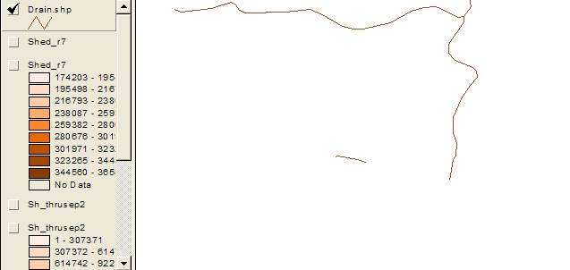

Release Note 1/25/2006 -- Headwater Node Catchment errors
Headwater node catchment areas were not calculated for some (typically very short) headwater flowlines. This is expected for very short headwater flowlines, however, it was discovered that a small percentage of headwater flowlines (about 0.1 percent) that should have received headwater catchments did not. The problem was corrected and fixed prior to the determination of the production of the headwater-node-areas files, but not before stream slopes and other flow characteristics were determined. In these cases a slope of zero was assigned and the flow characteristics were determined based on regression equations that assumed that the slope of the reach is unknown.

