NHDPlus Release Notes for
Region 08
Last Updated 8/2/2010

Data Release Note – 8/2/2010 – Flowline_Cat_Attr V01_03 Released

Two changes have been made to the FlowlineAttributesFlow Table: (1) All zero slopes have been changed to a nominal slope of 0.00005; and (2) the corresponding MAVELU and MAVELV estimates have been updated using the Jobson “slope” method for all Flowlines where these slopes have been changes. The result of this change is that the Jobson “noslope” method is never used. The reason for this change is that the NHDPlus Team has determined that the “noslope” method is not appropriate for zero slope applications. The Jobson velocity calculations are described in Appendix A- Step 6 of the NHDPlus User Guide.

Data Release Note – 10/17/2008 – NHD Component V01_03 Released
NHDFlowlineVAA.StreamOrde was set to zero to indicate that users are directed to use the new Stream Order/Stream Calculator fields that are available from the Data Extensions tab on the www.horizon-systems.com/NHDPlus web page.

Release Note 04/28/2008 – The problem with prj.adf parameter Zunits has been corrected in the elev_cm grids.

Release Note 12/13/2006 – Re-release of Region 08.
Region 08 was re-released to correct some minor issues in the NHD component (V01_02) and to implement the NHDPlus versioning scheme in all components. The only data content changes occurred in the NHD component. All other components contain the same data as the original release.

Release Note 12/11/2006 – Incorrect Major Divergent Path on the South Platte River
In NHDPlus10L, at the divergence downstream of flowline 3557318, the wrong path is designated as the major path in the divergence. Consequently, all of the NHDPlus cumulative attributes are routed down the major path which ends in a network termination and does not return to the South Platte. This results in an under counting of all cumulative attributes beginning with flowline comid 3557304 and continuing downstream through part of hydrologic region 07 (starting at flowline comid 3624763 on the Mississippi River) and along the Mississippi River to the bottom of hydrologic region 08. In total, 49413 sq km of cumulative drainage area is lost beginning at flowline 3557318 in NHDPlus10L.

Release Note 11/30/20006 – Missing Catchments
Between HydroRegions 8 (in blue, to the left) and HydroRegion 3 (Pearl River unit 318) (in green, to the right) there are 4 coastal flowlines that do not have catchments. This occurred because these coastal reaches were assigned to the wrong processing unit during processing of the data. The area in gray should have been assigned to coastal flowlines with comids 908130078, 908130080, 908130076, 908130079, and 908130077 (total length 3.8 km).

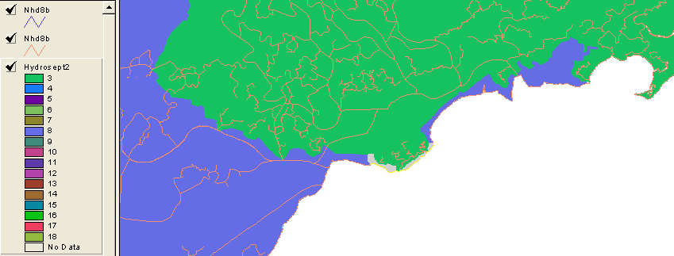

Release Note 11/8/20006 – Drainage Area
Note that the downstream ends of the Mississippi River from Region 07 and the Ohio River from Region 05 enter at the upstream end of the Mississippi River in Region 08. Therefore, the drainage area and UROM flow at the upstream end of the Mississippi River in Region 08 is the sum of the results from Regions 05, 06, 07, and 10. Gage 07032000 is on the Mississippi River at Memphis and the drainage area and UROM flow are the sum from all of these upstream Regions plus the Region 08 contributing areas above Memphis. Gage 07289000 is on the Mississippi River at Vicksburg and also includes the flows from the White and Arkansas Rivers in Region 11. At these two Gages, the NHDPlus drainage areas are 6% less than the Gage areas. This difference is most likely due to the accumulated effects of NHDPlus reflecting contributing drainage areas versus the Gages reporting total drainage area. There are some other drainage area discrepancies that occur in complex areas such as bayous, or the Gage is located on the minor path of a divergence. Also, NHDPlus underestimates drainage areas in the St. Francis River Basin due to a significant number of un-networked drainage ditches. Other than these cases, the NHDPlus drainage areas match the Gage drainage areas well.

Release Note 11/8/20006 – Flow
The NHDPlus mean annual flows tend to match the Gage values well, except in the outlier situations described above for Gage drainage areas. The UROM and Vogel NHDPlus flows should be considered reliable estimates in Region 08.

Release Note 11/08/2006 – Reaches without Measures – This problem was fixed in the V01_02 release of the NHD Component
All reaches in Region 08 now have measures.

Release Note 1/25/2006 – Source Elevation Data
Elevation Data (grid format), for all Hydro Regions except for Hydro Region 5 (the Ohio River Basin), were retrieved, July 2004, from the National Elevation Dataset (NED) maintained by the U.S. Geological Survey.

Release Note 1/25/20006 – Watershed Boundary Data (WBD)
Only certified WBD was included for use as a “wall” drainage enforcement factor in HydroDEM production. These data are tiled by U.S. State, therefore only selected states with full certification were used. The publication date for each state's WBD varies. The following are the states (and WBD publication dates) for those states that were certified at the time of catchment production, that have drainage to the Mississippi River.

Alabama, 2004

Release Note 1/25/20006 – Headwater Node Catchment errors
Headwater node catchment areas were not calculated for some (typically very short) headwater flowlines. This is expected for very short headwater flowlines, however, it was discovered that a small percentage of headwater flowlines (about 0.1 percent) that should have received headwater catchments did not. The problem was corrected and fixed prior to the determination of the production of the headwater-node-areas files, but not before stream slopes and other flow characteristics were determined. In these cases a slope of zero was assigned and the flow characteristics were determined based on regression equations that assumed that the slope of the reach is unknown.

